

How to Create a GitHub Account

A step-by-step guide to setting up a new GitHub account for the Endur → GitHub migration.
Important: please read before you start
- All users must follow the standard username convention below, so accounts are uniform across the team.
- If you already have a GitHub account, do not reuse it. Please discard any existing personal GitHub IDs and create a new account following this standard, so all project accounts are consistent and correctly governed.
- Use your Uniper work email address when creating the account.
Username Standard (mandatory)
- All GitHub usernames must follow this format: KID-<last name>
- Example: a user with last name Chevireddy → KID-Chevireddy
- If the resulting username is already taken append number1 to keep it unique (e.g. / KID-Chevireddy1), while staying as close to the standard as possible.
Step 1: Go to the GitHub Signup Page
Open your browser and navigate to: https://github.com/signup

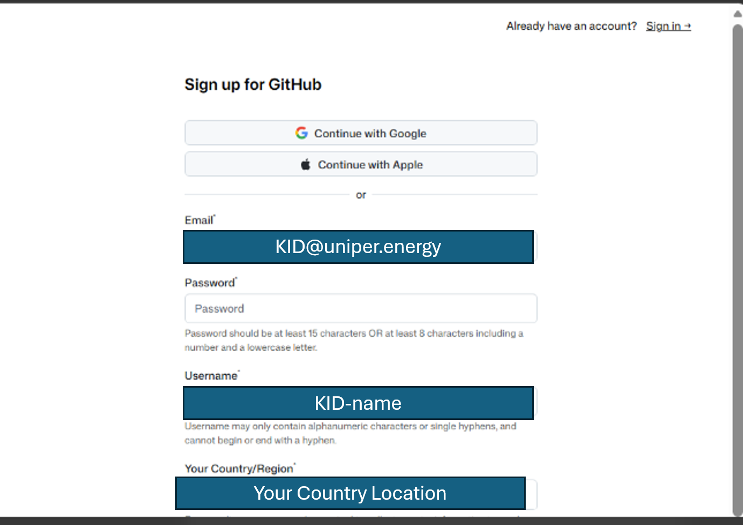
Step 2: Enter Your Email Address
Type in the email address you want associated with your account, then click Continue.
Step 3: Create a Password
Choose a strong password (at least 15 characters, or 8+ characters with a mix of numbers and lowercase letters). Click Continue.
Step 4: Choose a Username – follow the standard
Enter Username using the mandatory convention: KID-<last name> (see above example)
This becomes part of your profile URL (github.com/yourusername) and is visible on all your contributions. Click Continue.
Step 5: Email Preferences
Choose whether you want to receive product updates and announcements via email (optional). Click Continue.
Step 6: Verify You're Human
Complete the puzzle/captcha verification GitHub presents.
Step 7: Verify Your Email Address
GitHub will send a verification code to the email you provided. Check your inbox, enter the code on the GitHub page, and confirm.
Step 8: Choose a Plan
Select the Free plan (sufficient for most individual users — includes unlimited public/private repositories). You can upgrade later if needed.
Step 9: Personalize Your Setup (Optional)
GitHub may ask a few questions about your experience level and intended use (personal projects, work, school, etc.). You can answer these or skip.
Step 10: You're Done!
You'll land on your GitHub dashboard. From here you can:
- Create your first repository (+ icon → New repository)
- Set up your profile (add a photo, bio, and links)
- Follow other users and explore projects

